**SCOIL TREASA’S VIRTUAL SPORTS DAY**

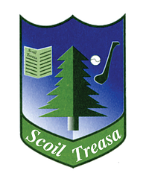

**Thursday, 18th of June 2020**

**You will need:**

* **A football**
* **A skipping rope (if you don’t have a skipping rope, tie two dressing gown belts or a few ties together)**
* **A welly**
* **10 skittles and a ball (the skittles can be tin cans or bottles)**
* **Four cones (if you don’t have cones you can use anything that will stay in place. I’m using bicycle helmets)**
* **A rugby ball**
* **A human**
* **A stopwatch/timer**