Scoil Treasa Poetry Competition: List of Winning Entries
A huge well done to all students who took part in our recent poetry competition.
Our judges thoroughly enjoyed reading through all the wonderful poems you sent in on the theme: ‘What Makes Me Happy’.
We have many talented poets in Scoil Treasa and it was very tough to choose one winning entry from each year group.
Here are the winning entries:
(Winners will receive a book voucher when we return to school.)
3rd Class: “My Toothless Dragon Teddy Bear” by Seán Keane (Ms. Murray’s class).
4th Class: “Happiness” by Ryan Mc Phillips (Ms. O’ Neill’s class).
5th Class: “Laugh, Smile & Giggle” by Finn Dargan and Jamie Carroll (Ms. Mahony and Ms. Carey’s class).
6th Class: “What Makes Me Happy” by Jessica Horan (Ms. O’Tuama’s class).
Here are the winning poems:

My Toothless Dragon Teddy Bear

I remember half my life ago
My toothless dragon Teddy bear
A birthday present from my bro
That filled my days with joy and care.

Together we played for hours each day
Saving the world from monsters
And sending the bad guys away

We cuddled and hugged
After each adventure we had
I tell him my secrets
And he holds my hand.

We don't spend the same time together
Or play as much as best friends forever
But he still knows how to make me happy and fair,
My toothless dragon teddy bear.

By Seán Keane,Winner, 3rd Class

Happiness

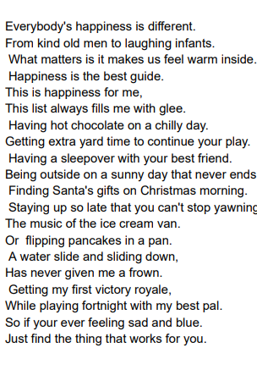-By Ryan Mc Phillips, Winner, 4th Class

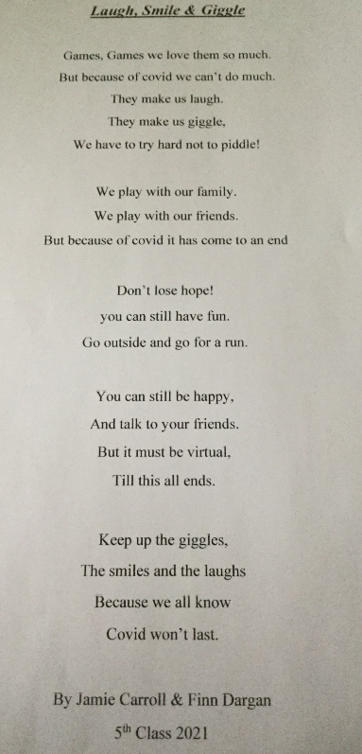
Winners, 5th Class

What Makes Me Happy
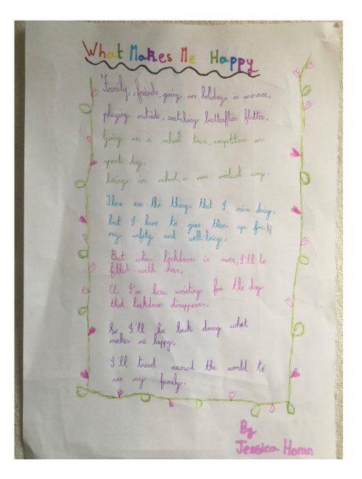
By Jessica Horan, Winner, 6th Class

Here are some of our other fantastic entries:

Ice-Cream Poem

Ice-cream is the greatest
As you can clearly see
An ice-cream factory is the place to be
So many “great” flavours
Oh so many to savour
Kinder, KitKat, Bubblegum
And Cookie Plum.

On that lovely summer’s day when you hear that siren ring
And the children dash to bring
All the money they have saved
Because they tried so hard to behave.

Now with the ice-cream in our hand
We have conquered Ice-Cream Land
Mr. Whippy is our hero
Next time I hope he brings Oreo.

-By Rachel Mooney, 3rd Class

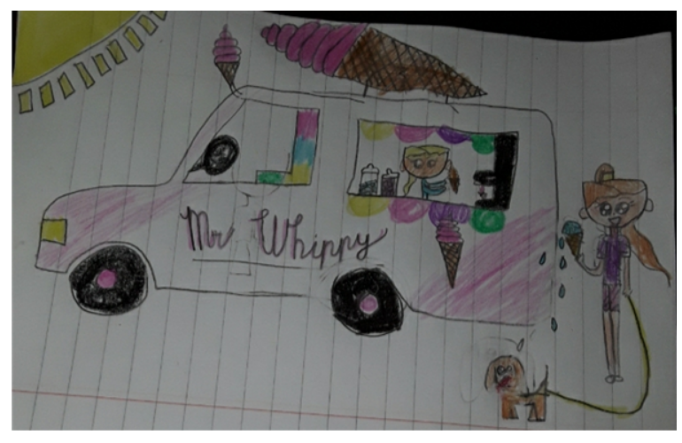

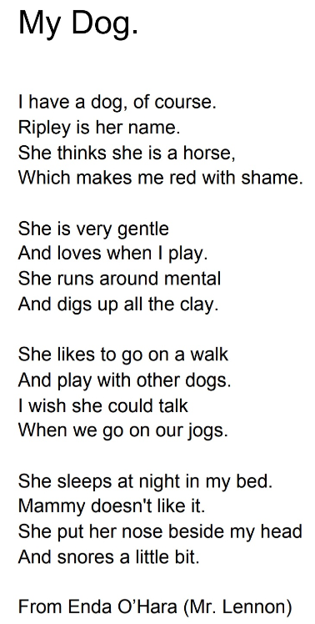

Four Friends
I am lucky to have four friends of my own,
We laugh, we play, we giggle and moan,
There are four of us here, we are never alone,
We play on the swings that are close to our home.

With scooters and bikes and footballs we play,
Outside in the fresh air all through the day,
Past the end of the road we do not stray,
In the summer we roll in the grass like its hay.

Four of us together,
Best friends we’ll be forever
Ninja’s in the nether,
All together we’ll be better.
By Jean McGourty, 3rd Class

The Secret to Enjoying Lockdown

Sometimes lock down can make you frown
But don't let lockdown get you all down.
Sometimes you’re going to laugh
But sometimes you're going to feel down

But we need to all get together over a Zoom
And not let this lockdown be all about gloom and doom!
Look out your window and the flowers will soon bloom
And listen to your favourite tune .

By Rory Farrelly, 4th Class

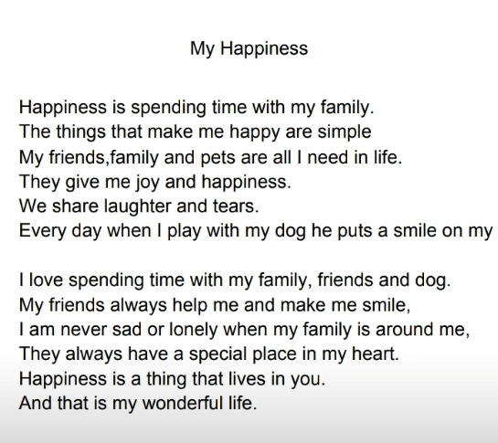

By Amy Little, 4th Class

Happy

Sometimes it’s hard to be happy when we are stuck indoors
I miss playing outside with my friends
But instead we have fun figuring out who the Imposters are
And play computer games until it’s time for bed.

Sometimes it’s hard to be happy
As I can’t meet up with my Aunty Emma
But instead we zoom, text, call, laugh and sing together
Nothing changes although it’s been forever.

Sometimes it’s hard to be happy as my favourite restaurants and movies are closed
But instead I relax with my Mom and Dad, bake cakes, get takeaways
And sit around in our comfy clothes!

Sometimes it’s hard to be happy as Covid-19 is here
But instead we enjoy walks, play games, dance and sing songs
Until things are different, next year.

By Lily Coventry, 4th Class

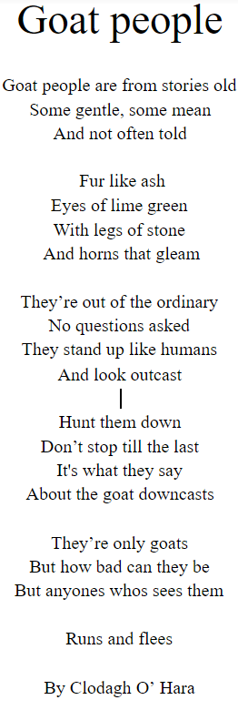5th Class

Spring

I wake up every morning to a dull and boring day.
I go to fetch my laptop and start to work away.
But WAIT! what is this?
A robin, a daffodil, a gentle mist?
Trees beginning to show their leaves
Spring lambs bouncing over my knees!
Such beautiful colours are surrounding me
Oh I hope to see my friends laughing with glee!

By Emily Goulding, 5th Class

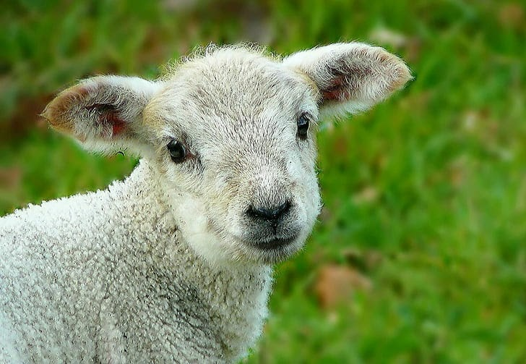

Summer
Summer is a lovely season,
And I have more than one reason,
We jump in the pool,
And we're not freezing.

We go outside and play with the ball,
We play a game and hide behind the wall,
We had a running race,
And tried not to fall.

I go to my friends place,
And we look through the telescope to outer space,
We look around for a while,
And see the Astronauts having a running race.

We go to the beach at last,
But my brother can't go in because he has a cast,
We make sandcastles and collect shells,
And we have a blast.

By Lucy Doyle, 6th Class

My Imagination

Sometimes after or before bed.
I imagine impossible scenarios in my head.
Those that let my imagination run wild.
A fun world suited for someone like me, a child.

Somedays I wish I could stay.
Because there's bees and sunflowers everyday.
The sweet scent of the fresh honey.
The cotton clouds for me to see.

So just remember that I'm still there.
With drawings and conversation to share.
Because my world isn't perfect, and I can't anymore fake or pretend.
I'm missing one thing, it's you, a friend.

By Chioma, 6th Class

Winter

Winter is my favourite season
I love waking up to the dark mornings, the frost, slippery paths and the crunchy white grass.

I Love walking in the snow as I watch it fall from the grey sky. The trees are full of snow, not a sight of green on the leaves.

I love the fire lighting in my sitting room, as I get cozy and watch a movie with my family.

I love to hear the wind and rain knocking on my window.
I love the bright moonlight shining into my window, when I am cosy in my bed.

By Layla O’ Reilly, 6th Class

