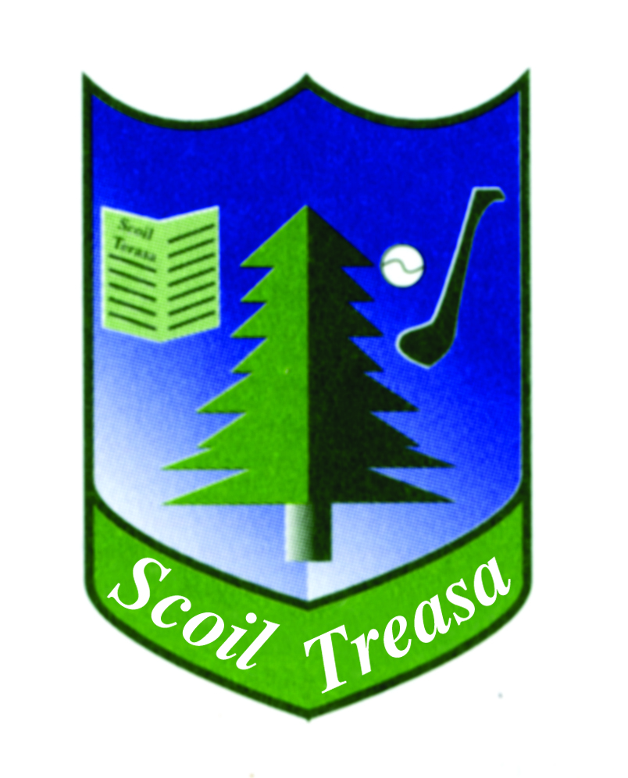
SCOIL TREASA
BOARD OF MANAGEMENT 2023 -2027
Boards of Management of primary schools are appointed for a four year term. The term of office for new Board of Management is from 1 December 2023 to 30 November 2027. The Board manages the school on behalf of the Patron, who is Dermot Farrell, the Catholic Archbishop of Dublin, and is accountable to the Patron and the Minister for Education. The Principal Teacher is responsible for the day-to-day management of the school, including guidance and direction of the teachers, SNAs and other staff of the school, and is accountable to the Board for that Management. All Boards of Management of primary schools assuming office from 1 December 2023 onwards are required to adhere to the provisions of the “Governance Manual for Primary Schools 2023- 2027”, a copy of which can be viewed at www.education.ie
The Board of Management consists of 8 members and meets between 6 – 8 times a school year. All meetings are held in Scoil Treasa and Fr. Peter Reilly is our Chairperson.

Patron’s Nominees: Fr. Peter Reilly
Mary Murray

Principal Teacher: Gerard O’ Meara

Teachers’ Nominee: Mark Walsh

Parents’ Nominees: Ruth Kinsella
Kevin Mention

Community Representatives: Jackie Martin
Nathalie Ward

Communication with the board can be made through the email chairperson @scoiltreasa.ie

Gerard O’ Meara, Secretary to Board of Management November 30th 2023

